1. Compress a file by compress, gzip, zip commands and decompress it again. State the differences between compress and gzip commands.

gzip file1

gunzip file1.gz

zip file3.zip file3

unzip file3.zip

compress => .Z extension , less common in modern Linux systems, and you might not find it installed by default on some distributions.

gzip => .gz extension , widely used and more prevalent in modern Linux systems.

in general, gzip tends to achieve better compression.

2. What is the command used to view the content of a compressed file.

zcat command for .Z files

gzcat command for .gz files

bzcat command for bz2 files

unzip -l for .zip files

3. Backup /etc directory using tar utility.

tar cvf myarch.tar /etc

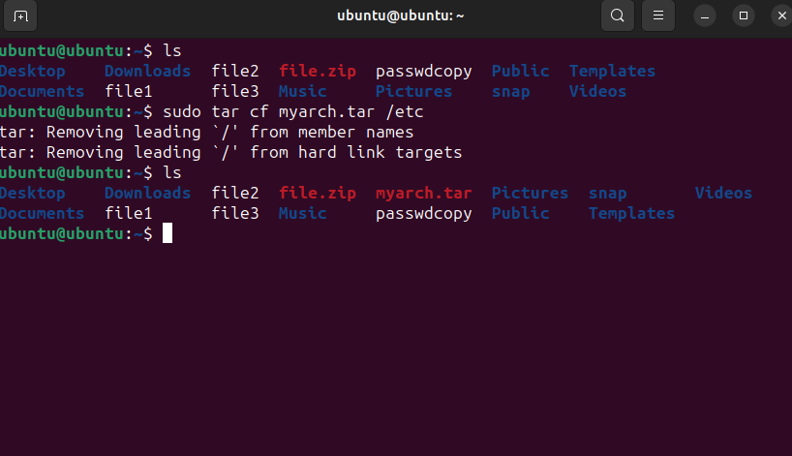

4. Starting from your home directory, find all files that were modified in the last two day.

find /home -type f -mtime -2 2>/dev/null

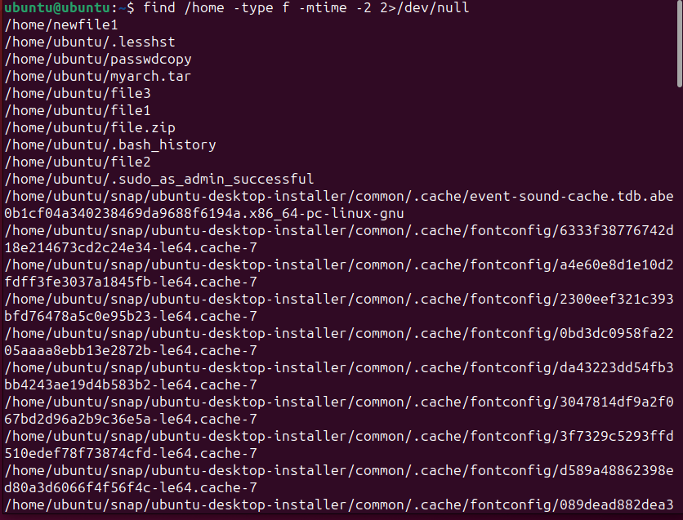

5. Starting from /etc, find files owned by root user.

find /etc -type f -user root

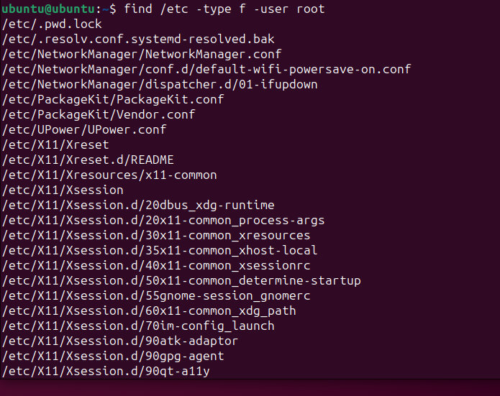

6. Find all directories in your home directory.

find /home -type d

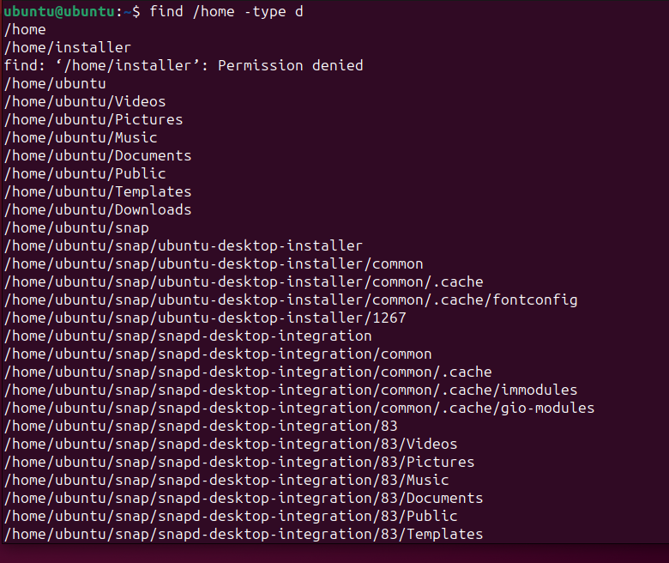

7. Write a command to search for all files on the system that, its name is “.profile”.

find / -type f -name .profile 2>/dev/null

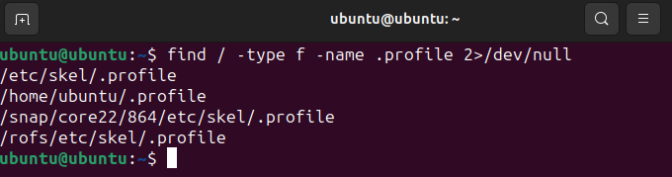

8. Identify the file types of the following: /etc/passwd, /dev/pts/0, /etc, /dev/sda

using the “file” command :

file /etc/passwd 🡺 ASCII text

file /dev/pts/0 🡺 character special (136/0)

file /etc 🡺 directory

file /dev/sda 🡺 block special (8/0)

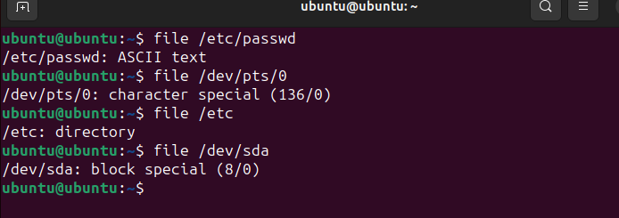

9. List the inode numbers of /, /etc, /etc/hosts.

ls -i /

ls-i /etc

ls -i /etc/hosts

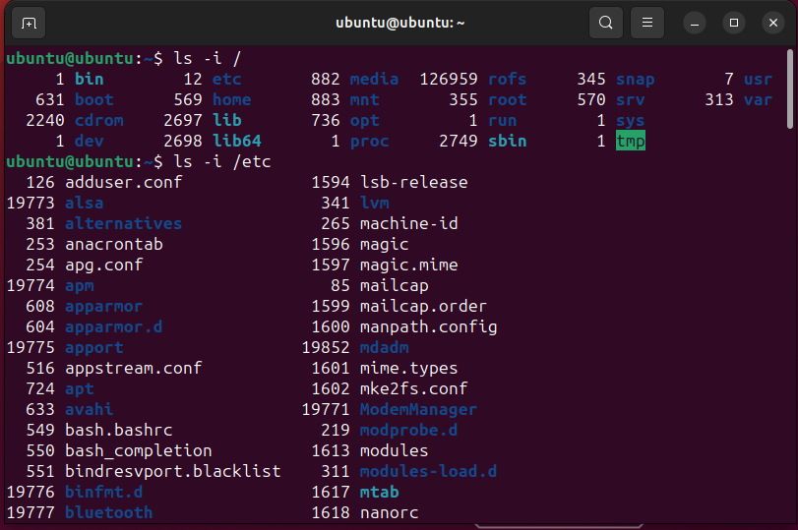

10. Copy /etc/passwd to your home directory, use the commands diff and cmp, and Edit in the file you copied, and then use these commands again, and check the output.

cp /etc/passwd ~/passwdcopy

cmp /etc/passwd ~/passwdcopy

diff /etc/passwd ~/passwdcopy

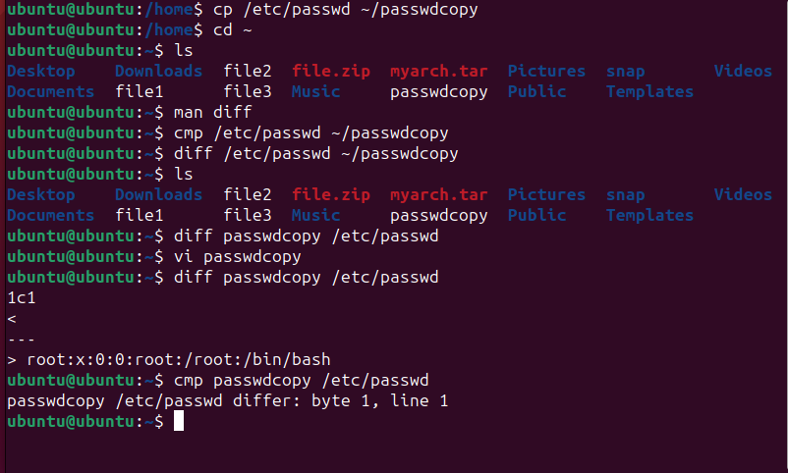

11. Create a symbolic link of /etc/passwd in /boot.

sudo ln -s /etc/passwd /boot

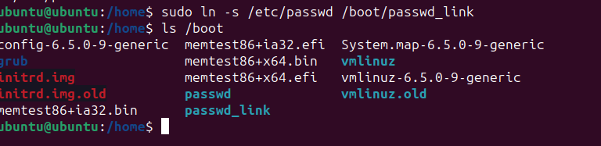

12. Create a hard link of /etc/passwd in /boot. Could you? Why?

sudo ln -s /etc/passwd /boot/passwd_hardlink

“had to use sudo because permission was denied”